**Create AWS Glue Job For Converting Json to Parquet File**

# **Introduction**

This exercise demonstrates how to create an AWS Glue job to convert JSON files into Parquet format, optimizing data storage and query performance. Using AWS Glue, you will configure a job to transform and load data efficiently, leveraging the service's managed ETL capabilities for seamless data integration.

# **Let’s get Started**

**Access AWS Glue Console:**

* Navigate to the AWS Glue Console using the provided URL, which directs you to the specific data catalog table tbl_customer_orders_with_addresses_json in the db_aws_training_exercises database within the AWS region us-west-2: <https://us-west-2.console.aws.amazon.com/glue/home?region=us-west-2#/v2/data-catalog/tables/view/tbl_customer_orders_with_addresses_json?database=db_aws_training_exercises&catalogId=786461327180&versionId=latest>

**Initiate Job Creation:**

* Click on "**Data Integration and ETL**" to access ETL features and then select "**ETL jobs**" to view existing jobs or create a new one.

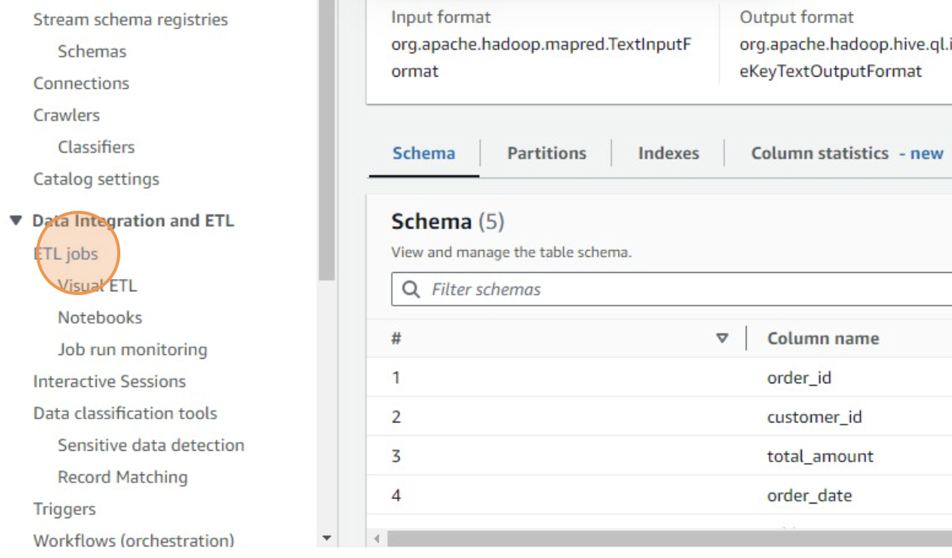

* Click "**Create job from a blank graph**" to start configuring a new Glue job from scratch, allowing for custom job setup.

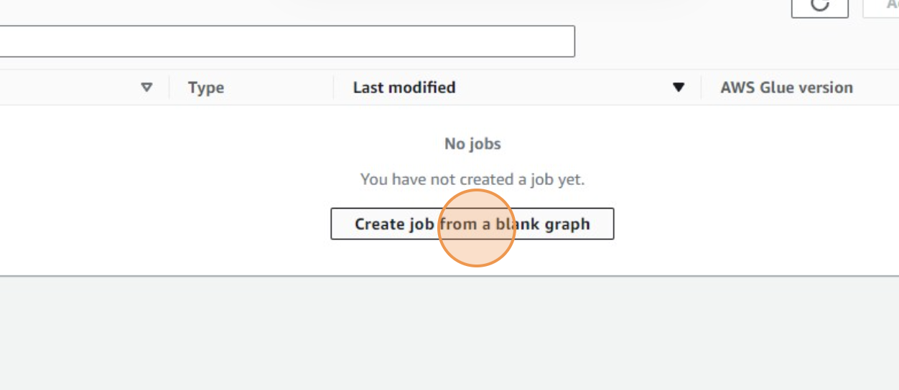

**Specify Data Source:**

* Choose "**AWS Glue Data Catalog table as the data source**" to use tables defined in the Glue Data Catalog.

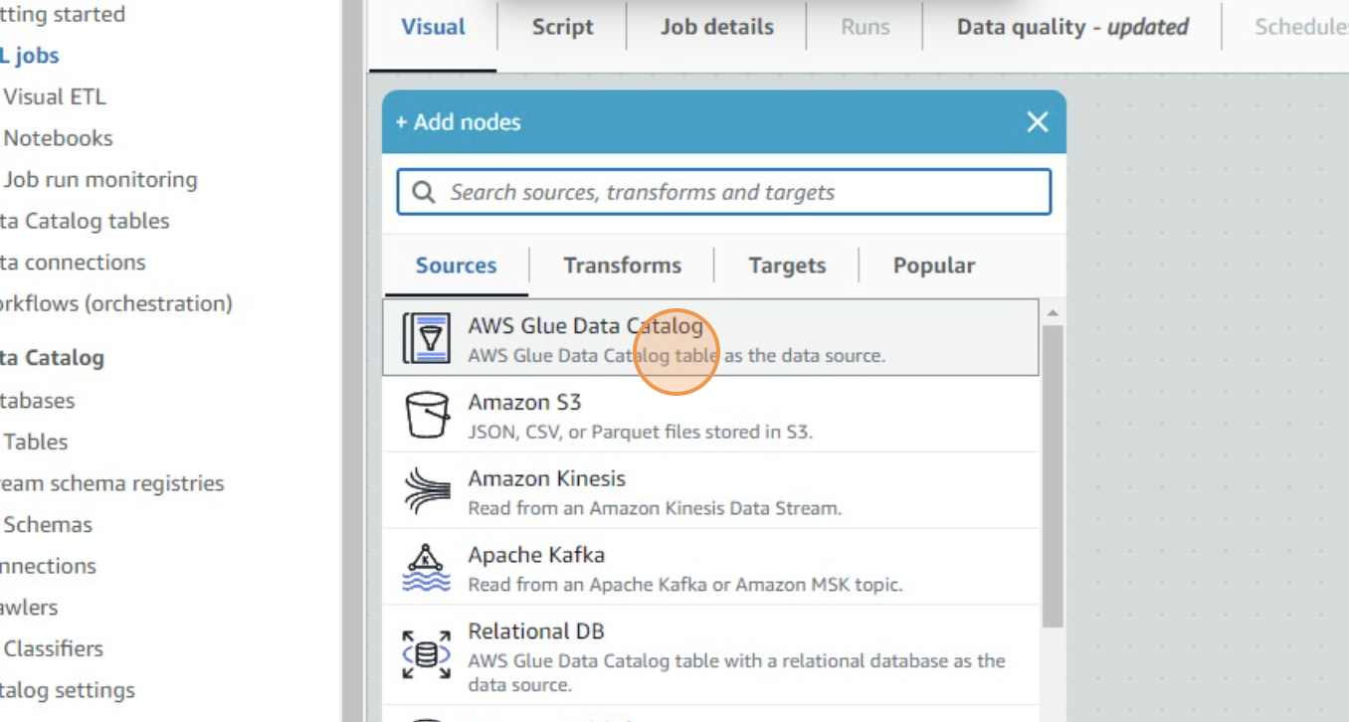

* Select "**Data source - Data Catalog**"

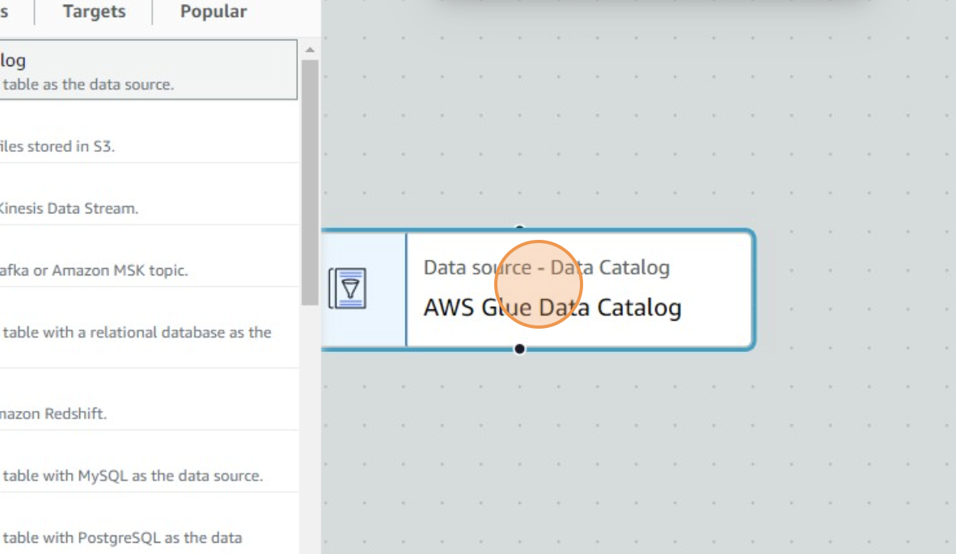

* Navigate through the catalog, and select the database db_aws_training_exercises

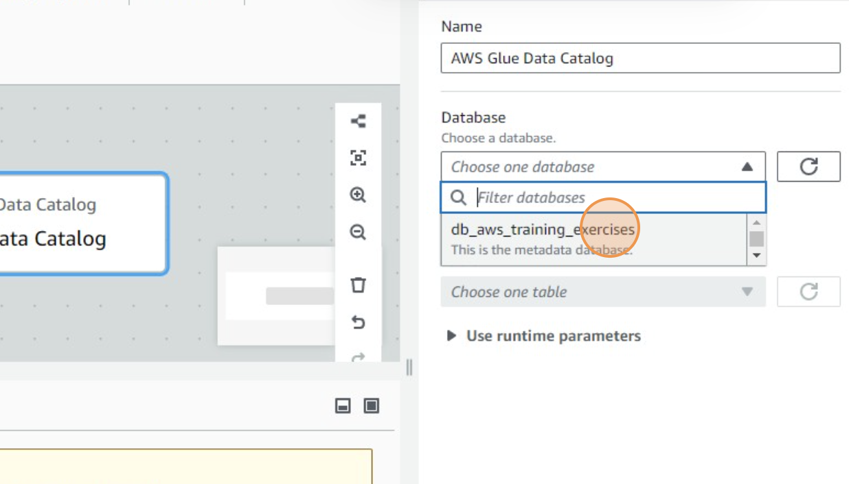

* Then select the table tbl_customer_orders_with_addresses_json. This table contains your JSON data

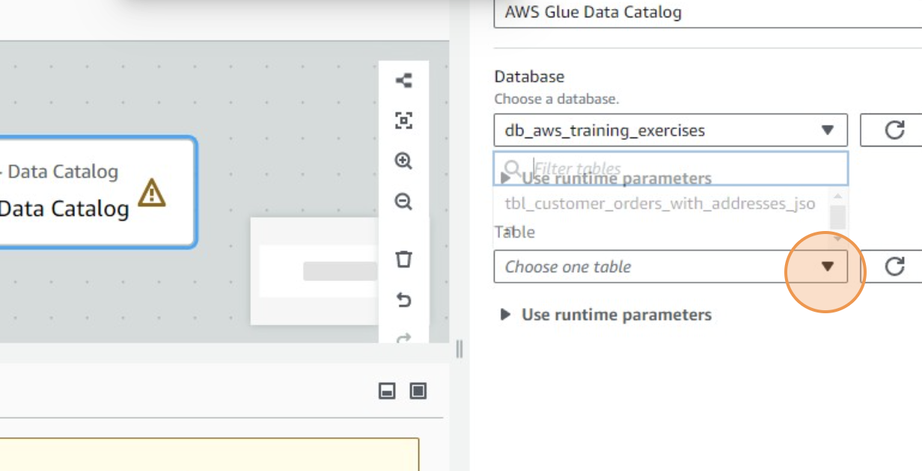

* Click on the expand icon, present on the top right corner of the page.

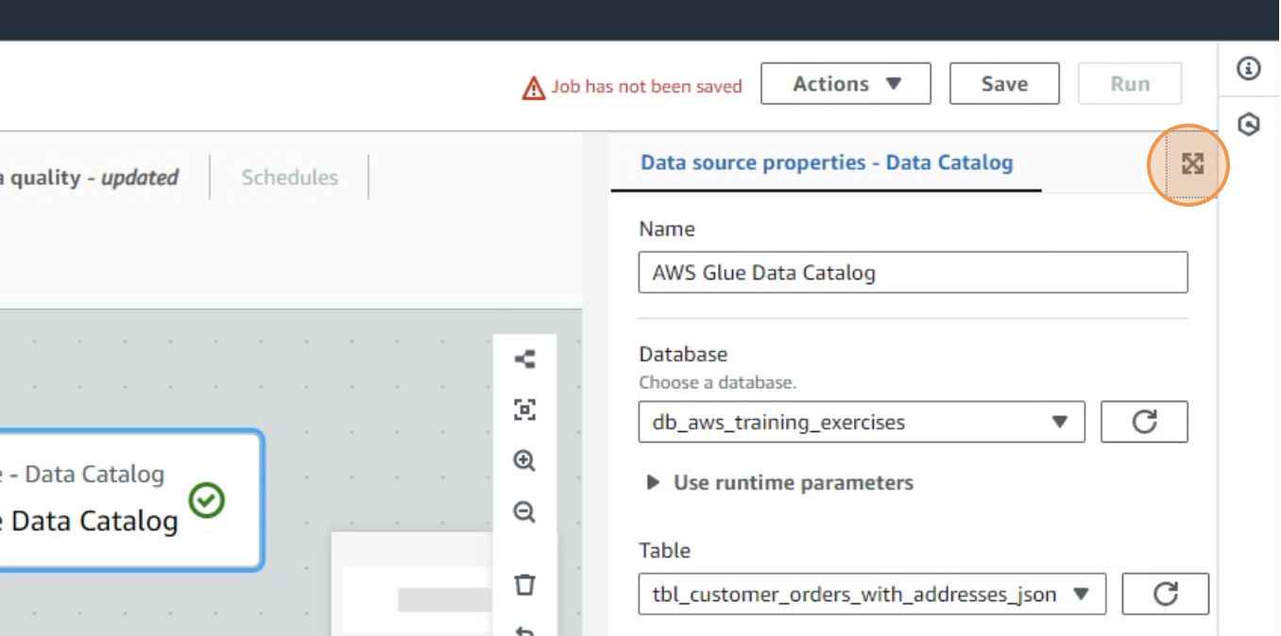

* Click on the Data Preview icon available on the top right corner of the page.

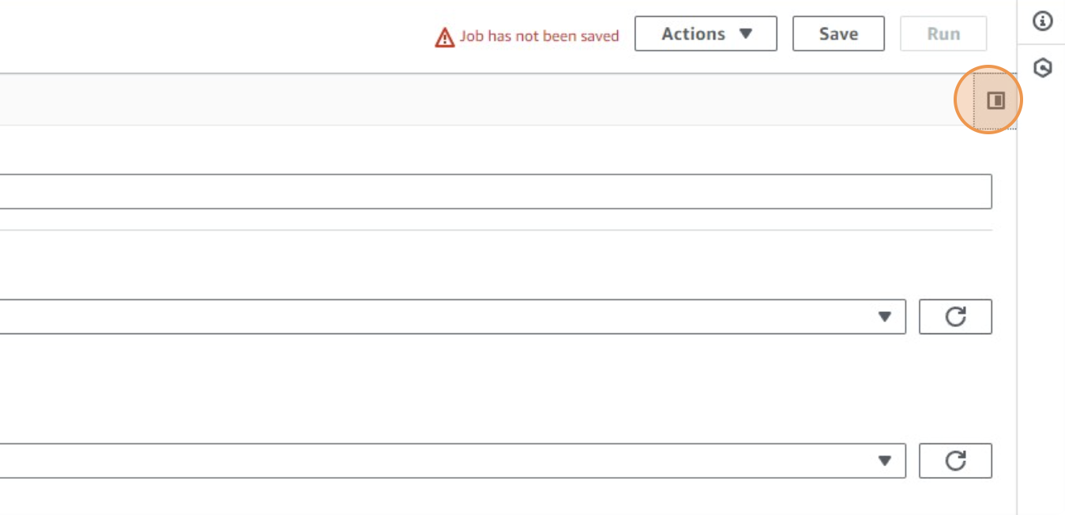

**Configure Job Properties:**

* Assign the role role_Glue_Training to the job, which should have necessary permissions for Glue operations and access to your S3 resources.

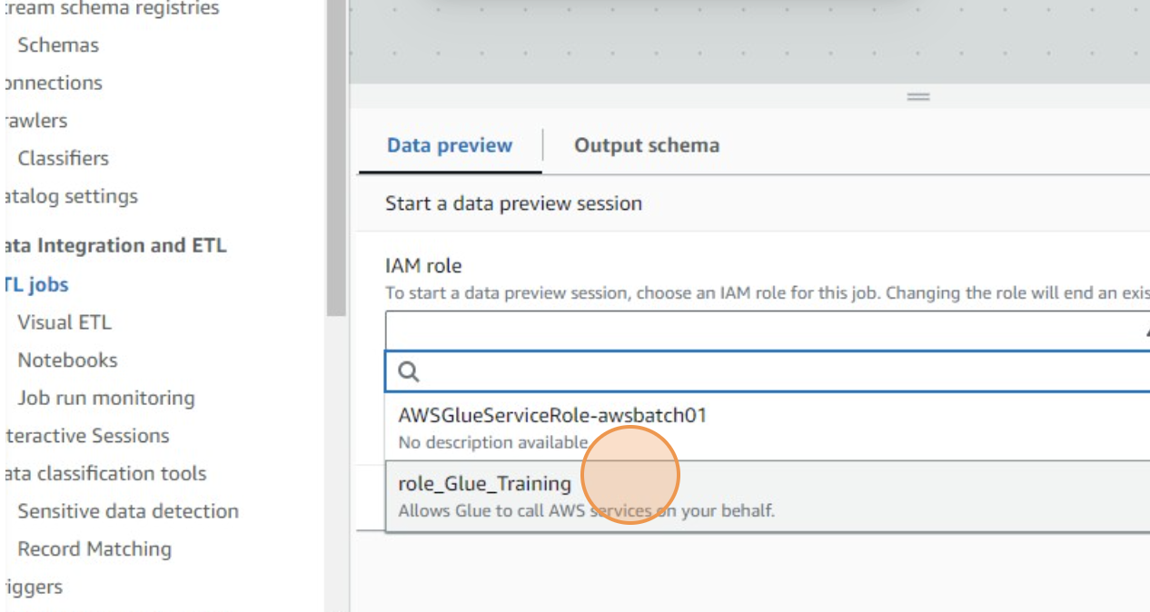

**Define Transformation:**

* Click on the + icon present on the top left corner of the page to add the transformation

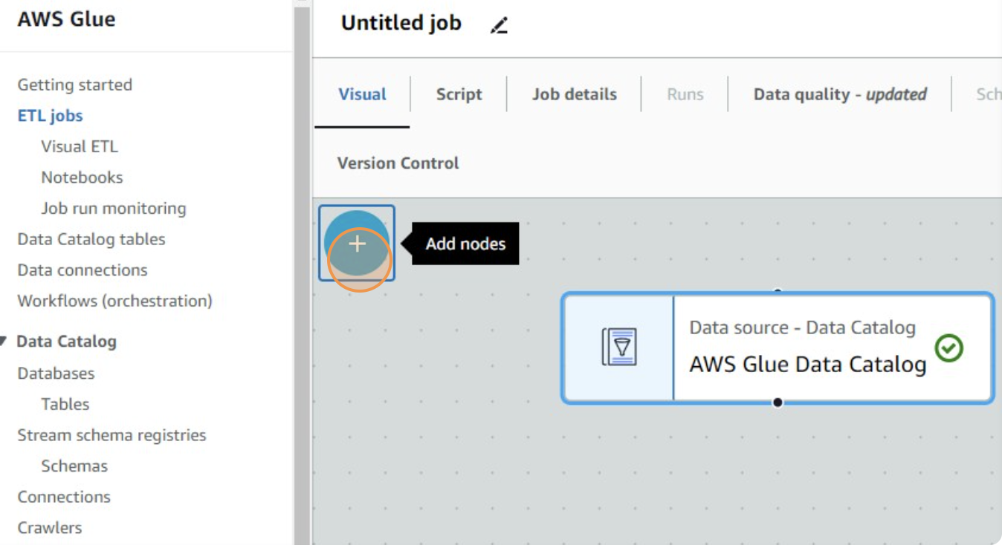

* Click "**Add Transforms**" to add data transformation steps. Here, you would define the conversion from JSON to Parquet format.

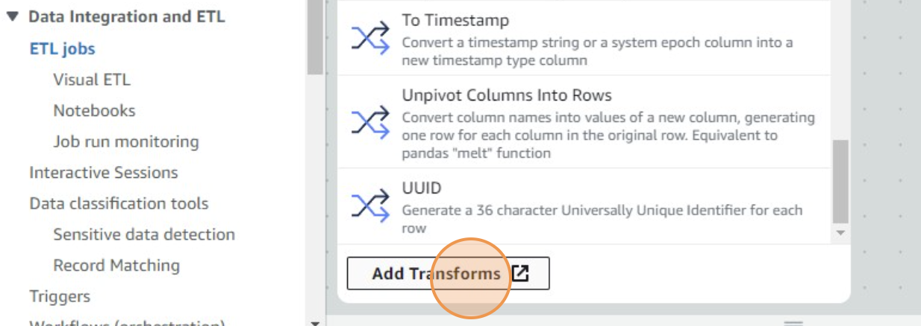

**Set the Target:**

* Go to **Targets** section

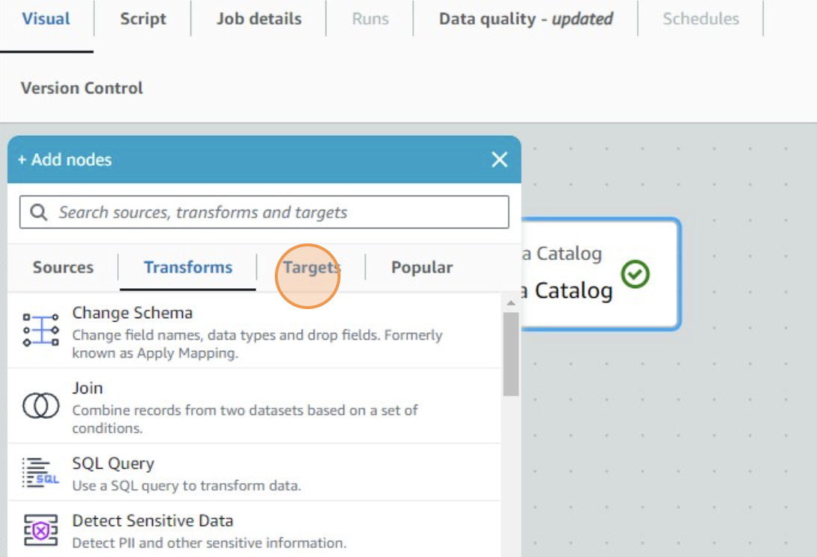

* Select "**S3 bucket”** by specifying a bucket path as the data target to define where the transformed Parquet files will be stored.

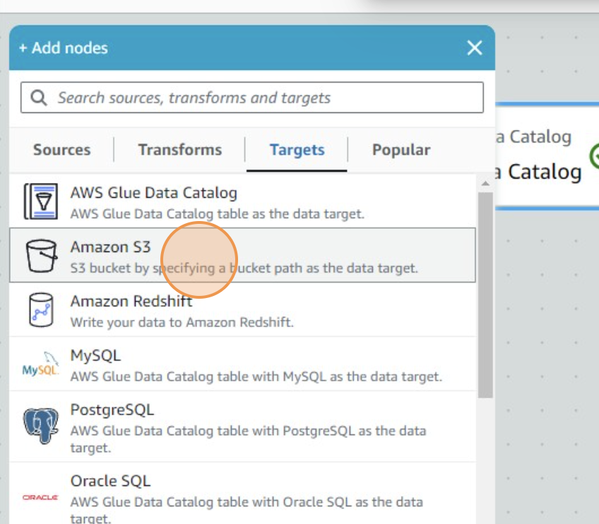

* Now click on the “S3 bucket” card.

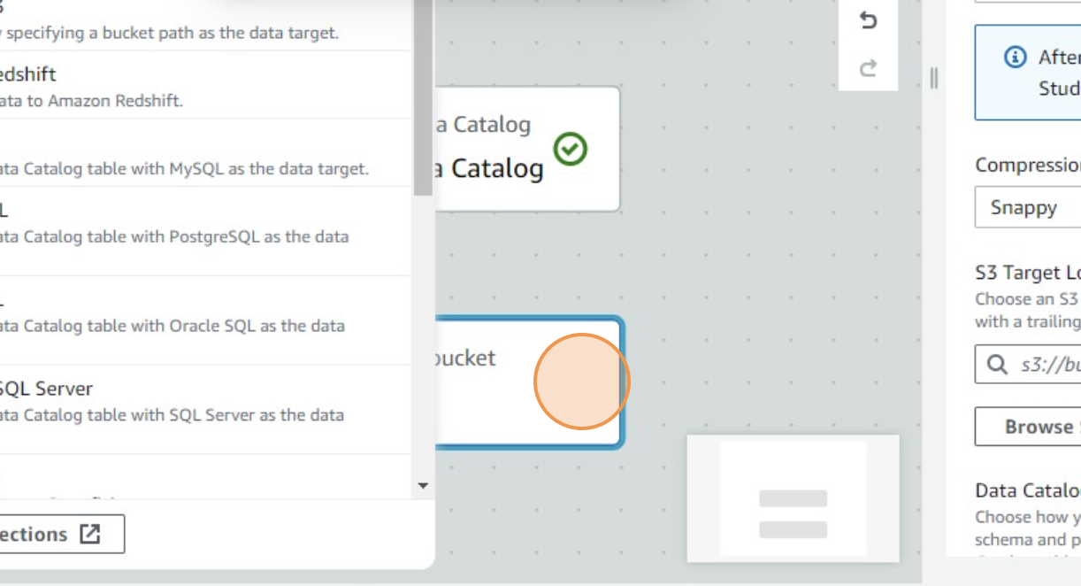

* From “**Data Target Properties**” tab, select **AWS Glue Data Catalog** as **Node Parents**

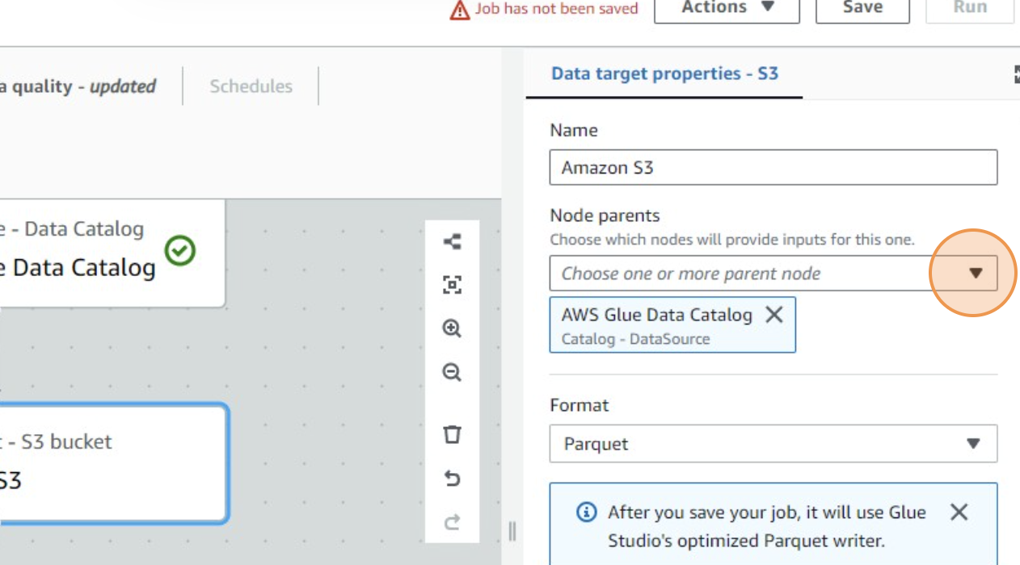

* Navigate to and select the S3 bucket awstrainingjune01 and specify the path where you want the Parquet files to be output.

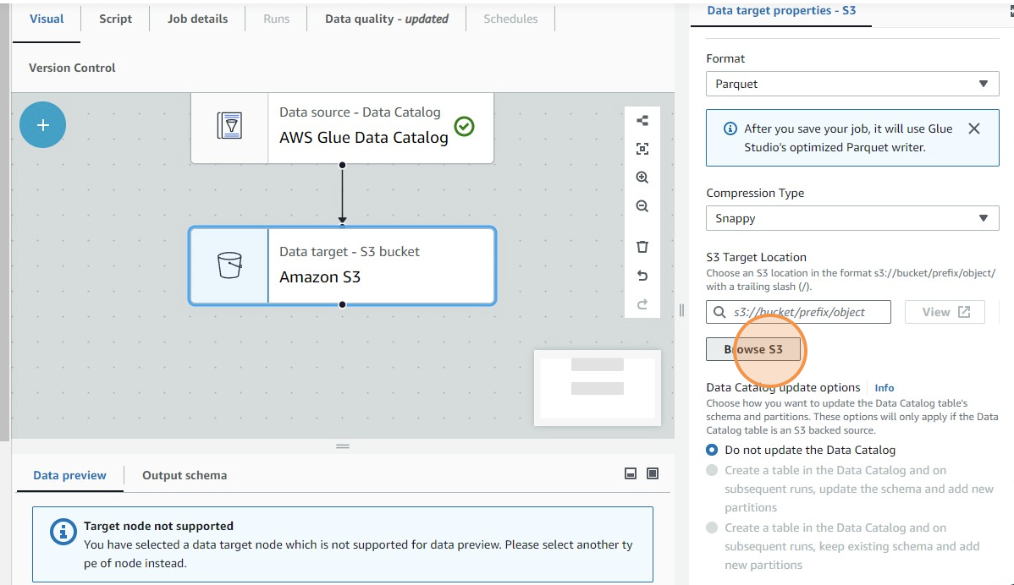

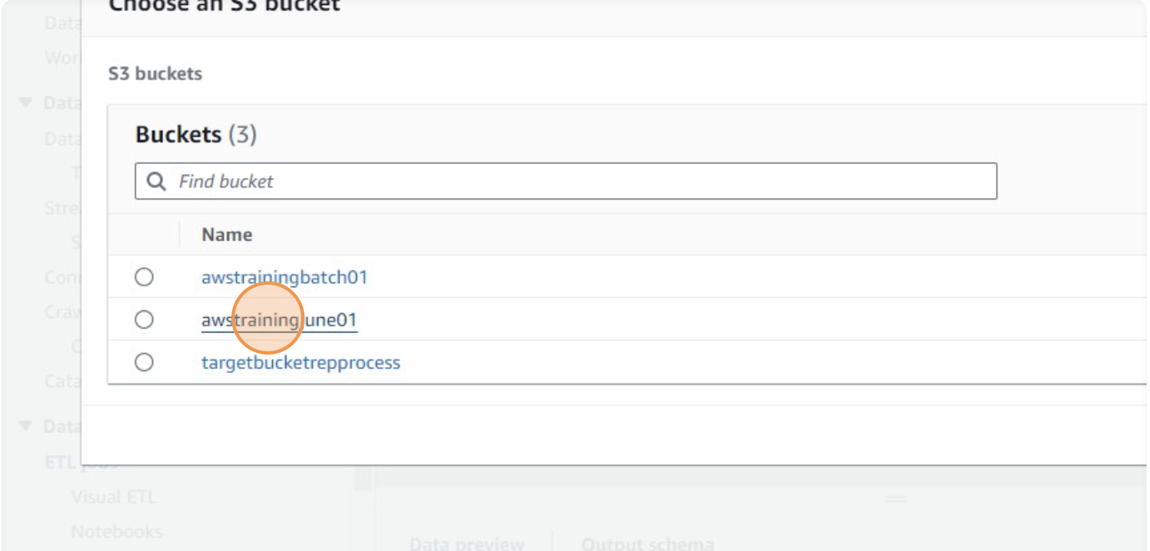

* Select **Output_Data/**

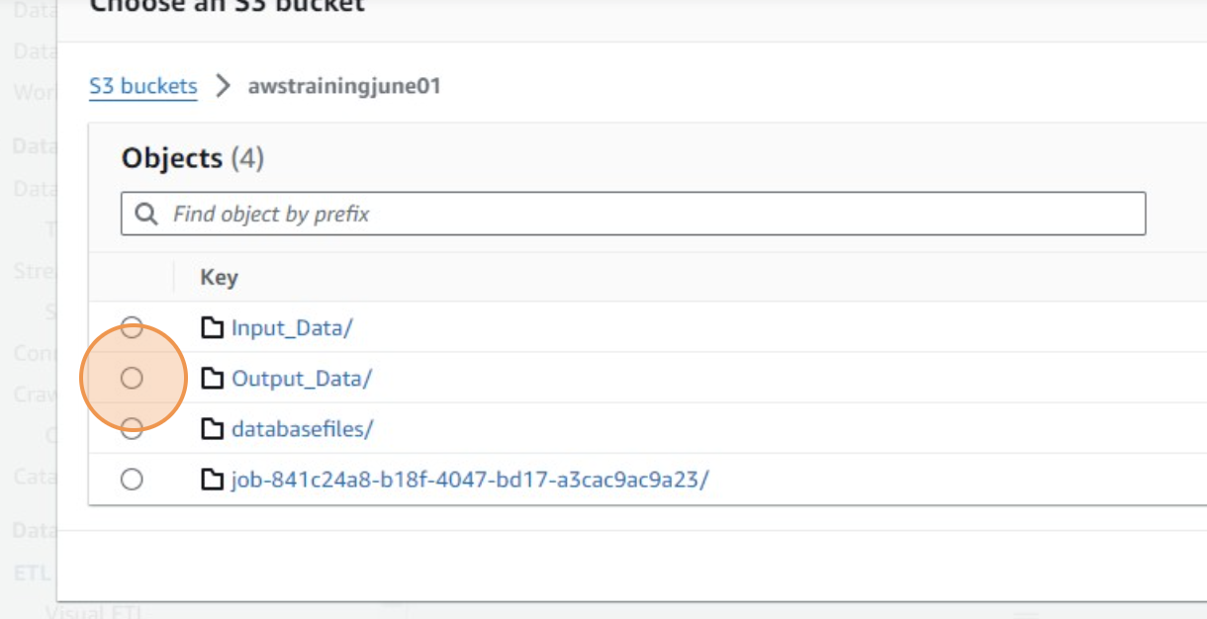

* Click on the “**Choose**” button, present on the bottom right corner of the page

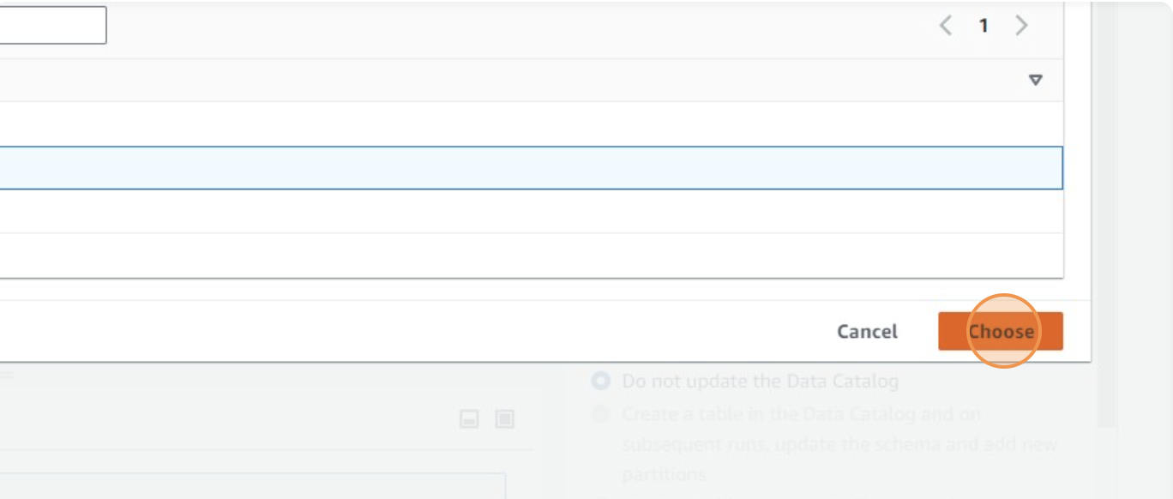

* Goto **Output Schema** tab, present on the bottom of the page

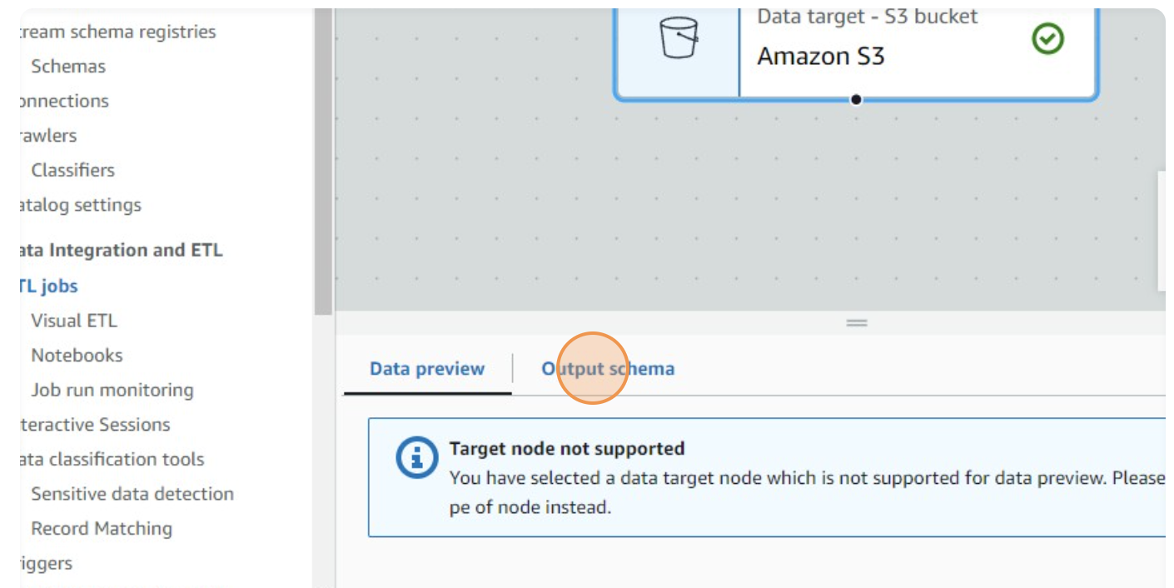

* Click on the **Actions** dropdown, present on the top of the page.

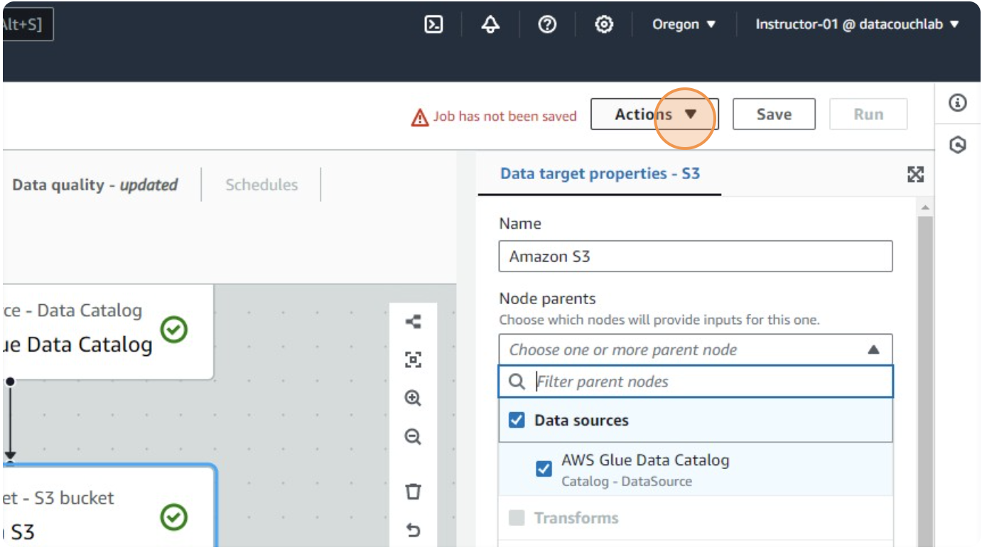

* Click on “**Job**”

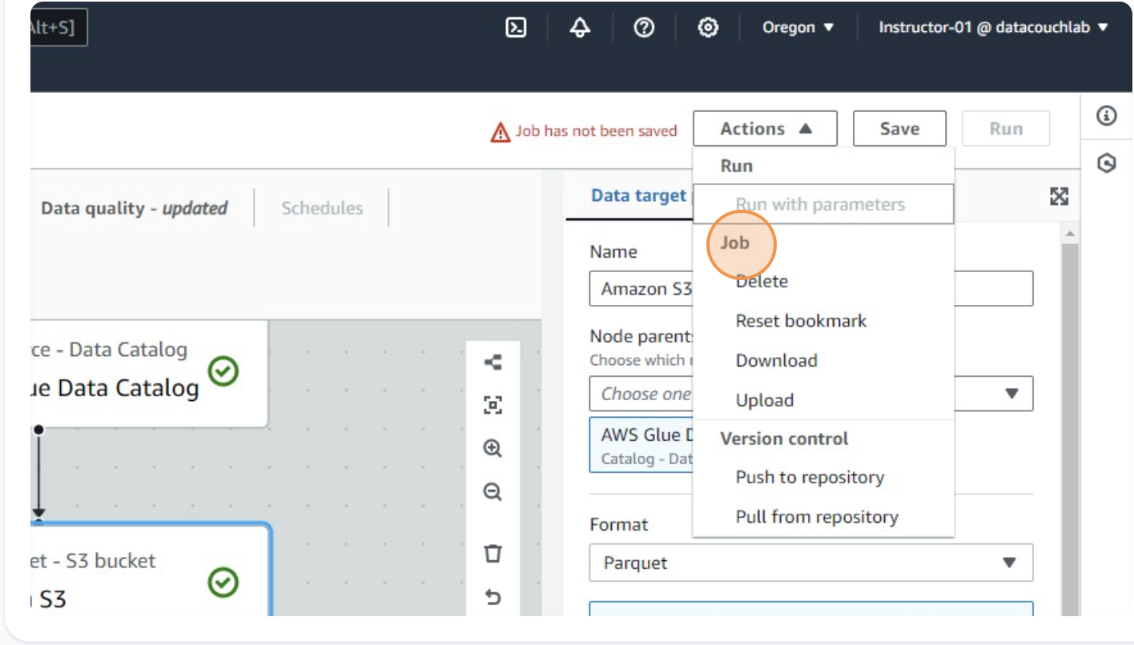

* Click on **Job details** tab

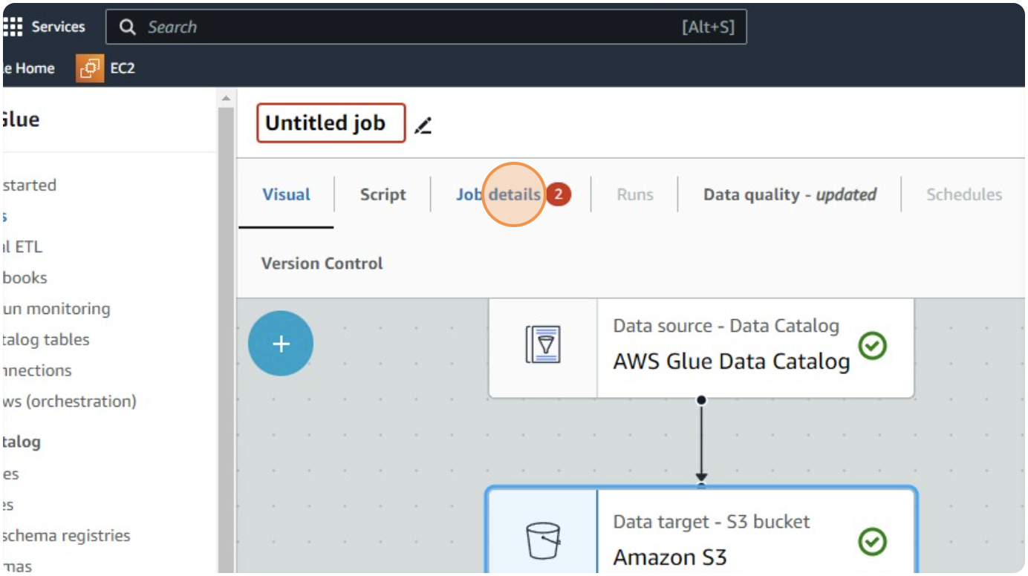

* Rename the job as "**job_json_2_parquet**"

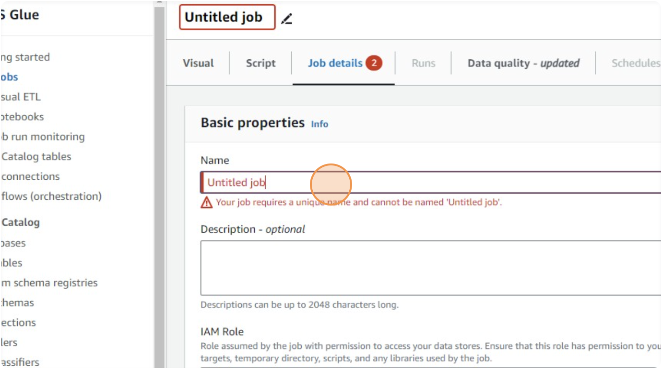

* Click the "**Requested number of workers**" field and change it as 5.

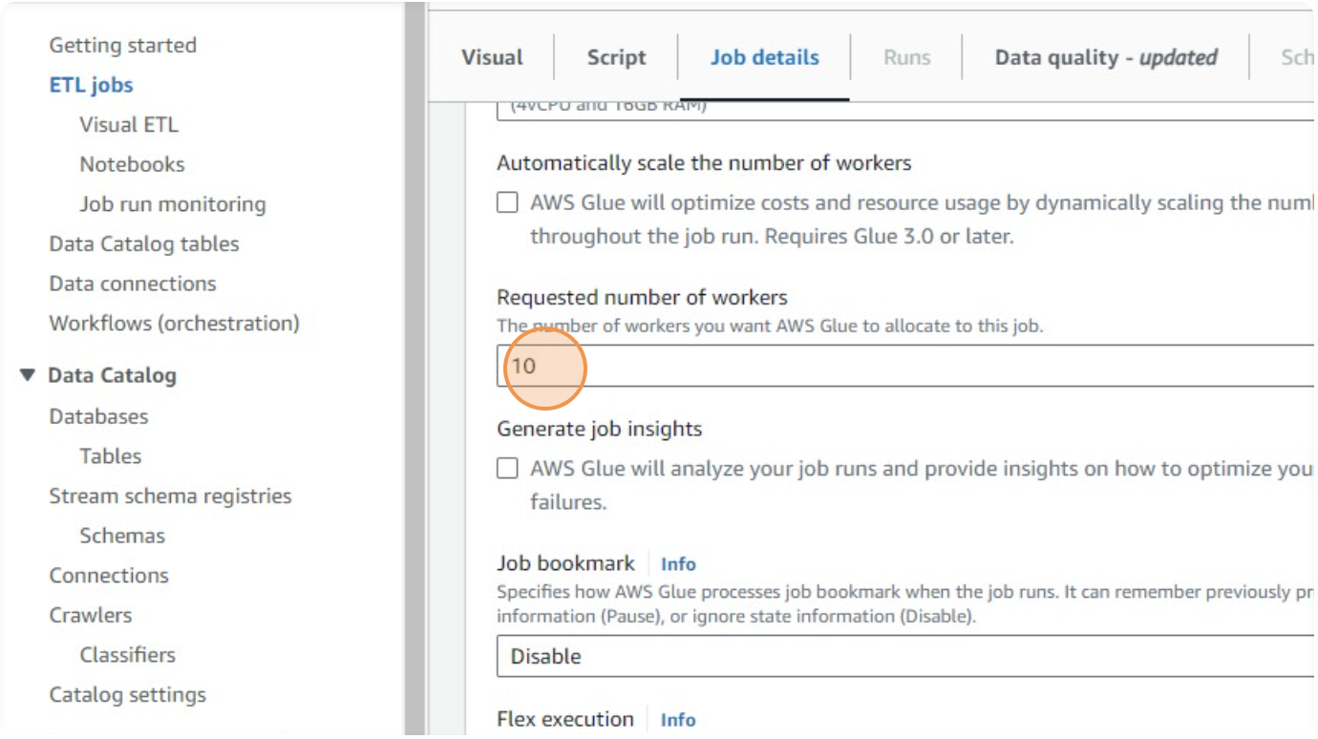

* Click on **Number of Retries** and change it to **2**

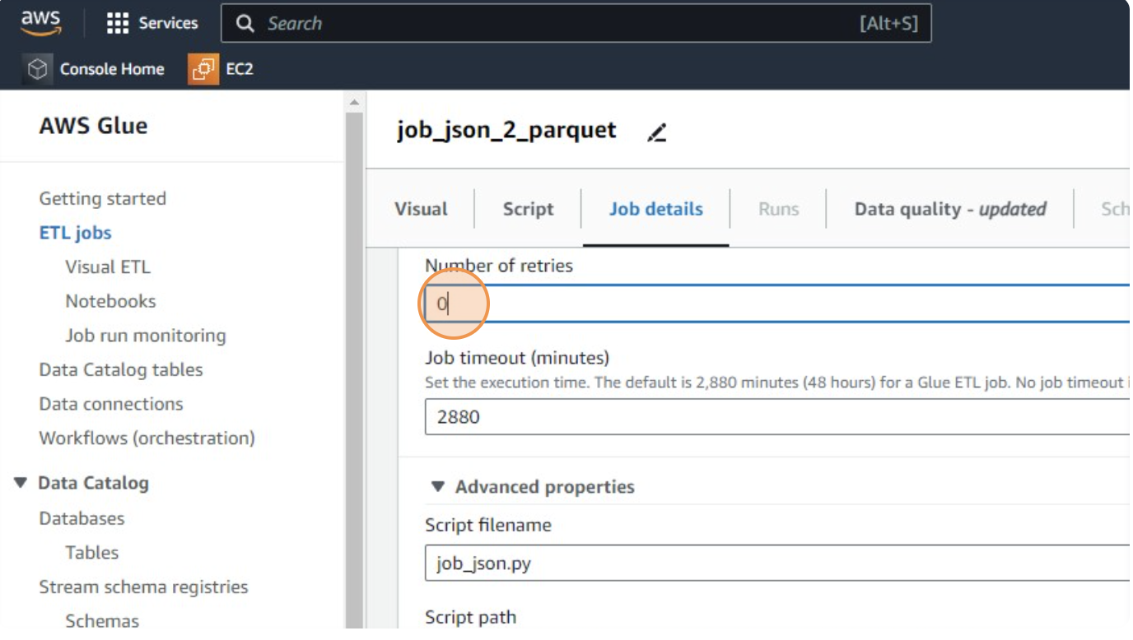

* Click the "**Script filename**" field and change it to **_2_parquet_file**.

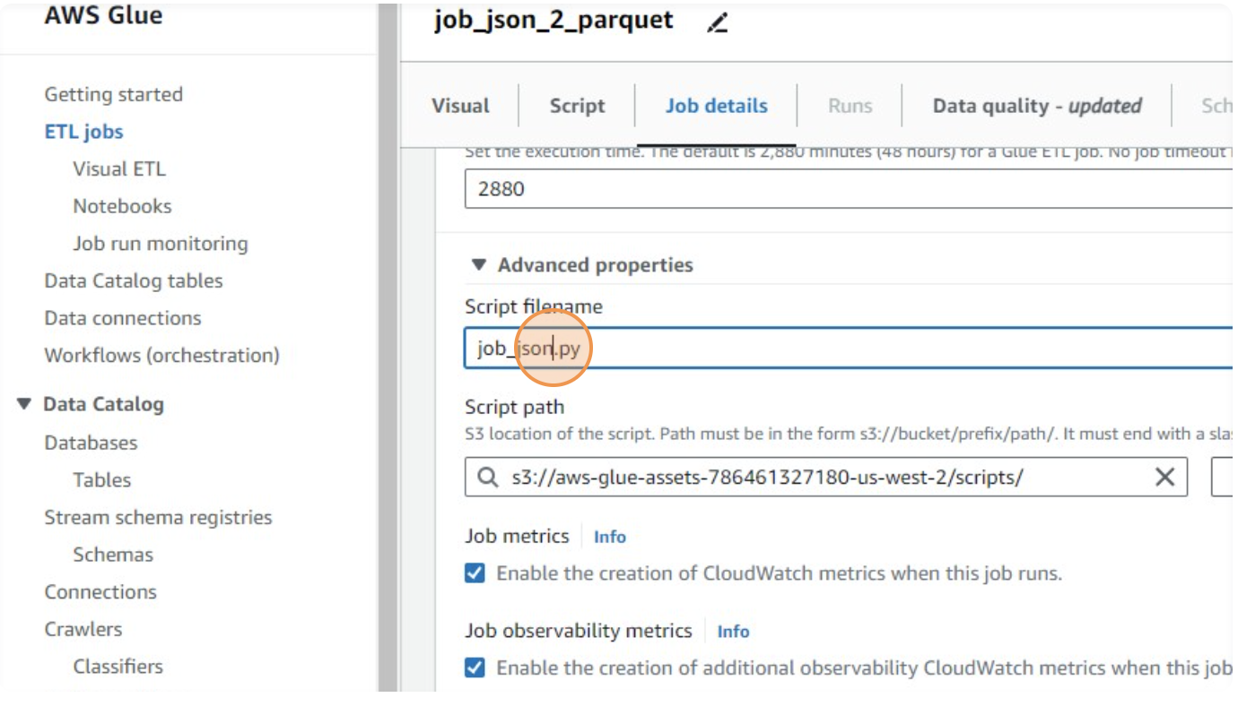

* Set the **script path** field

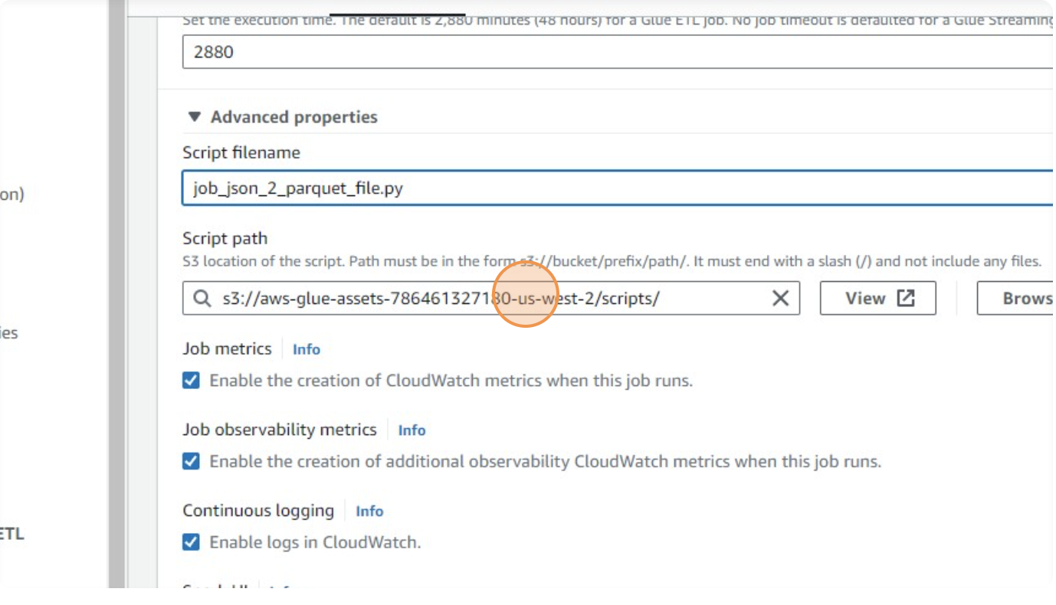

* Set the **Spark UI logs path**

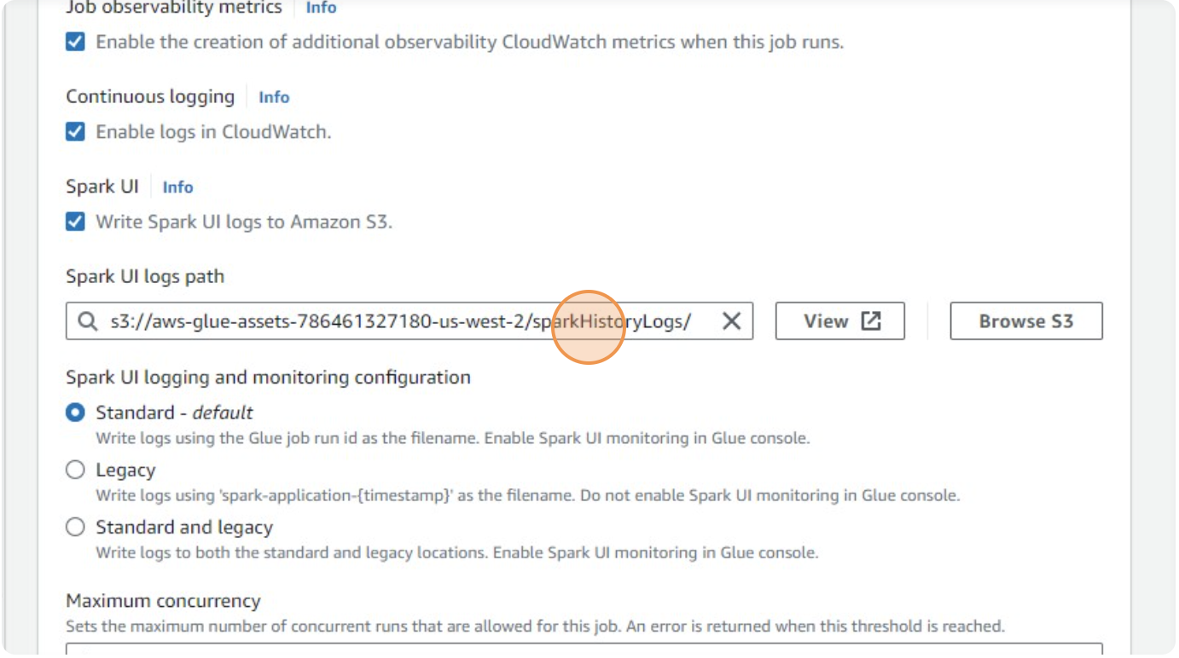

* Click the "**Maximum concurrency**" field and set it as **1**.

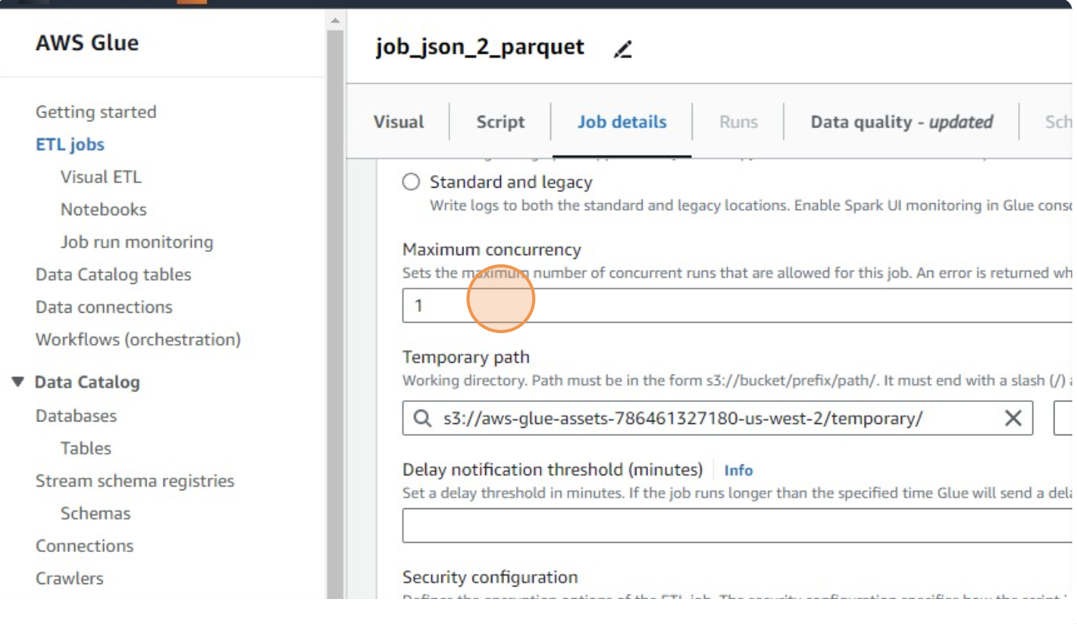

* Configure the **Temporary path**

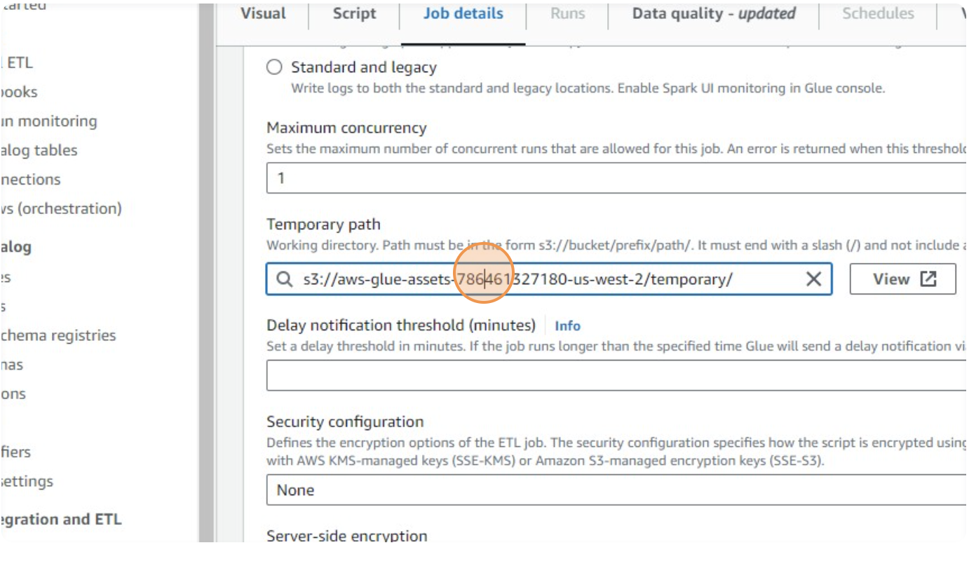

* Click on the **Save** button, present on the top right corner of the page

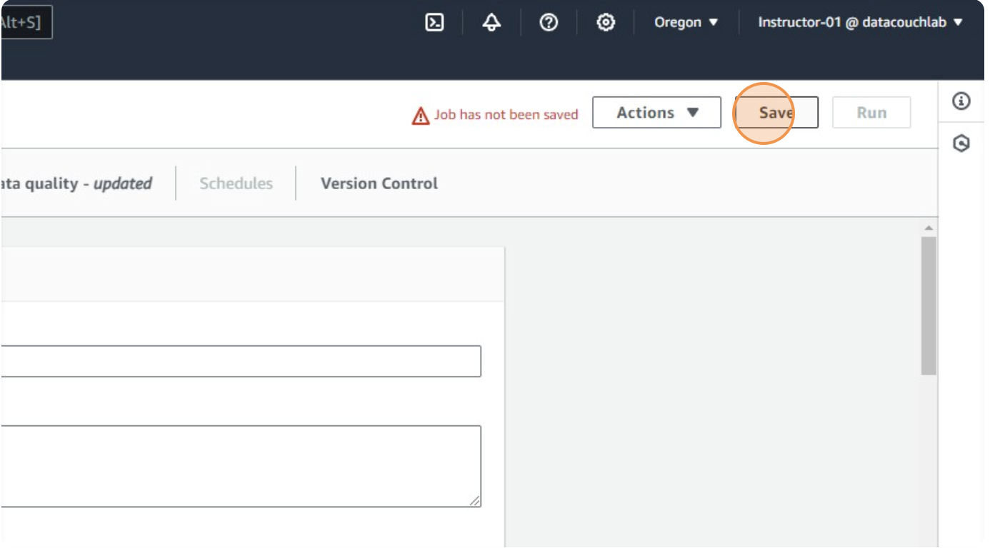

**Run the Job:**

* After saving all configurations, click "**Run**" to start the job.

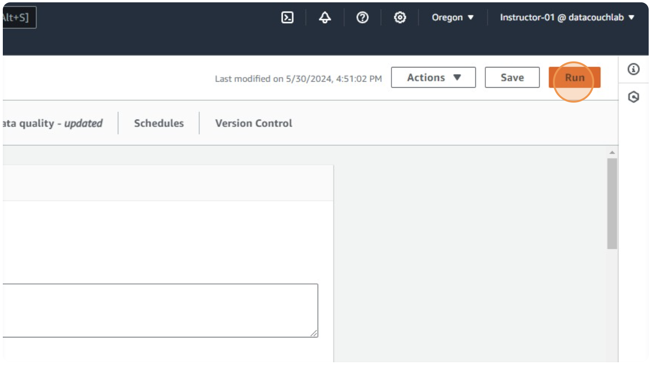

* You can monitor the job's progress under "**Runs**" and "**View Details**" to ensure it executes as expected

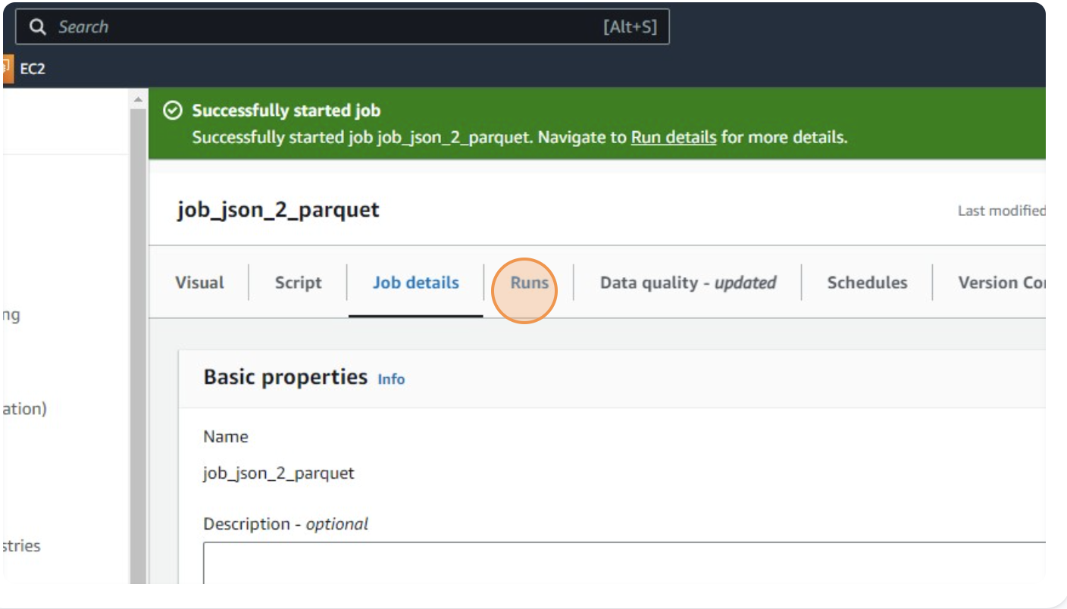

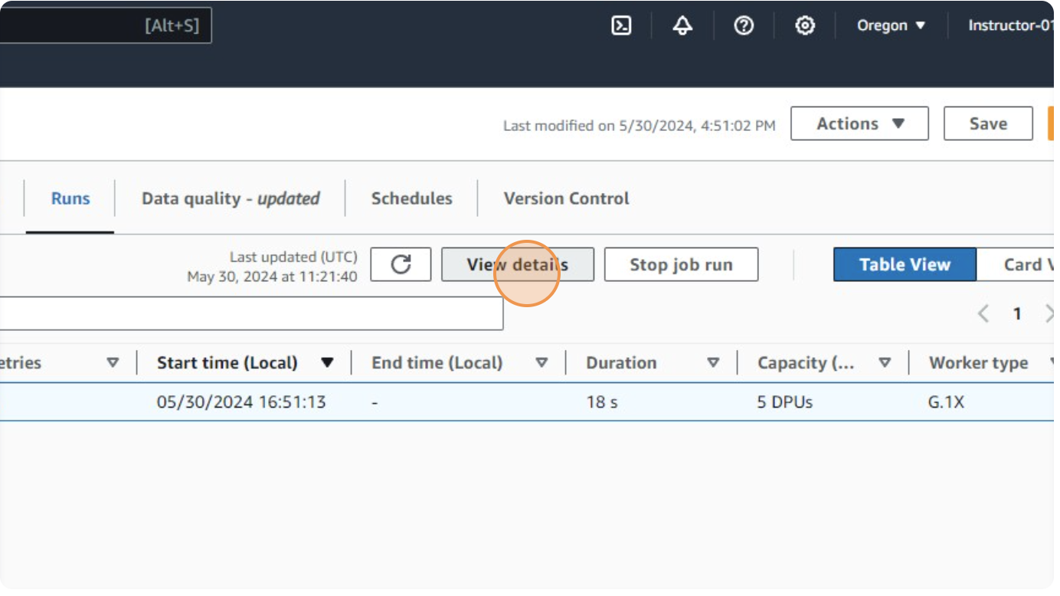

* Go to Spark UI, from **Data Integration and ETL** > **ETL Jobs** from the left hand section of the page.

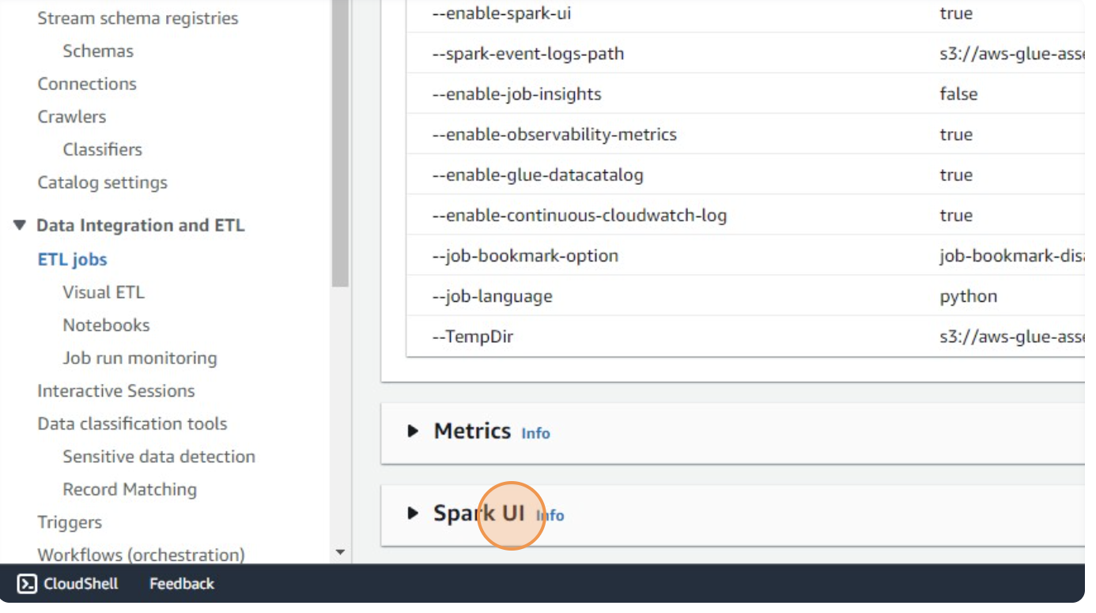

* Go to **Monitoring > Job Run** for monitoring the running job

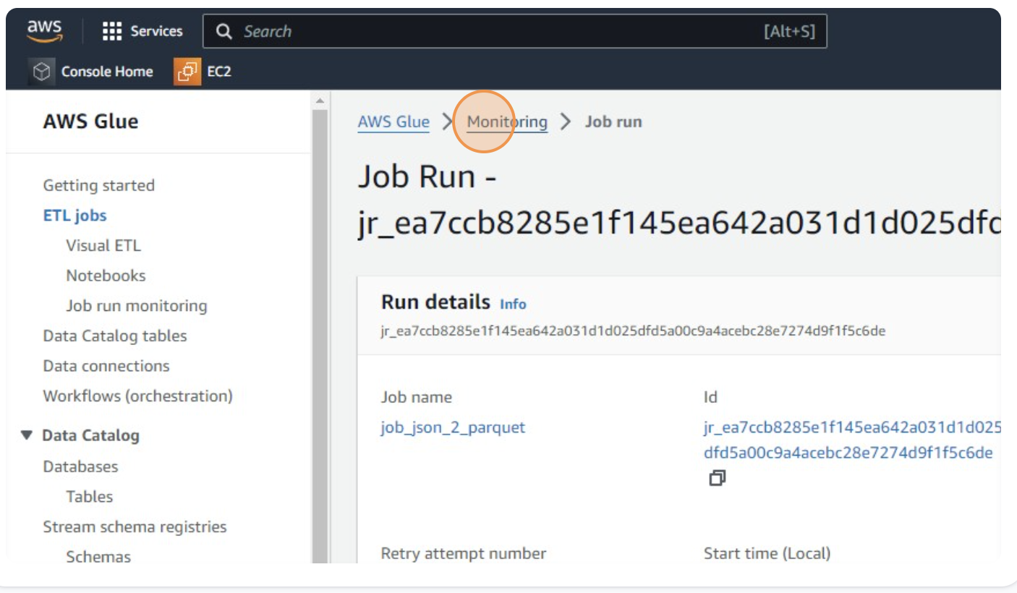

* Upon job completion, Navigate to the S3 bucket

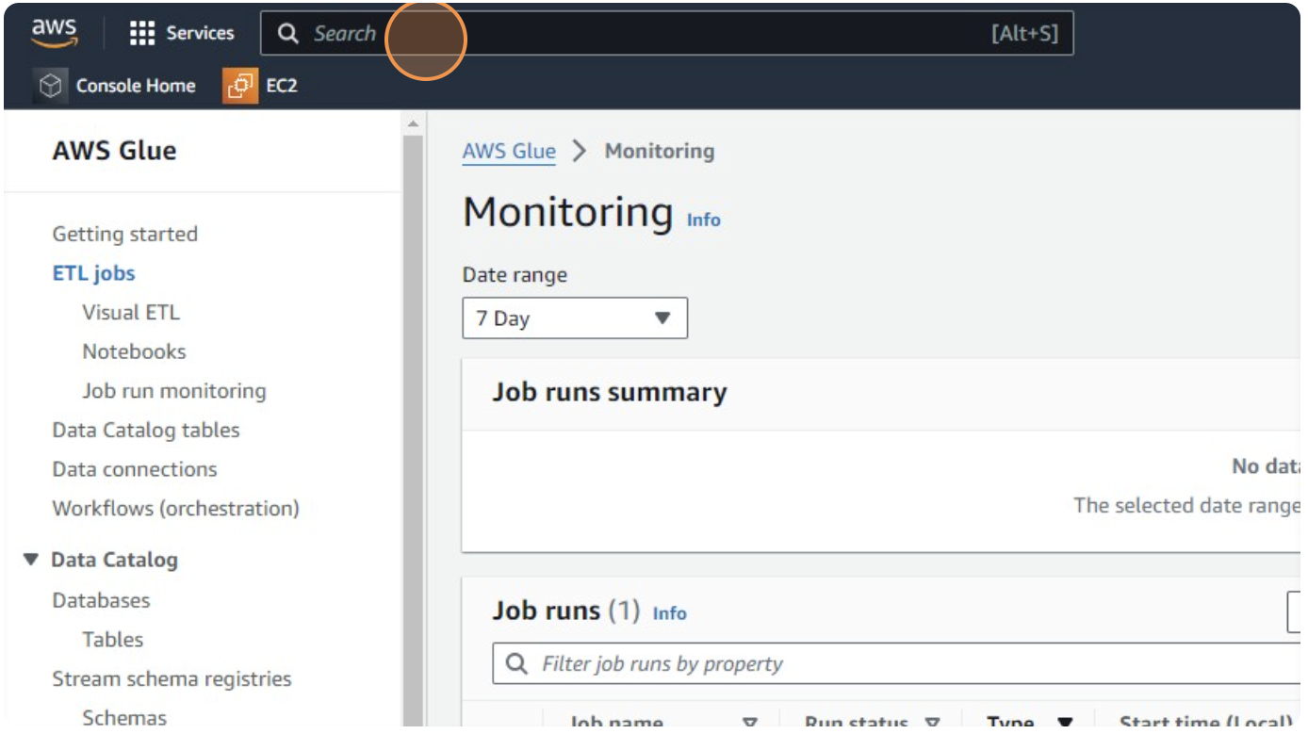

* Click on "**awstrainingjune01**" bucket

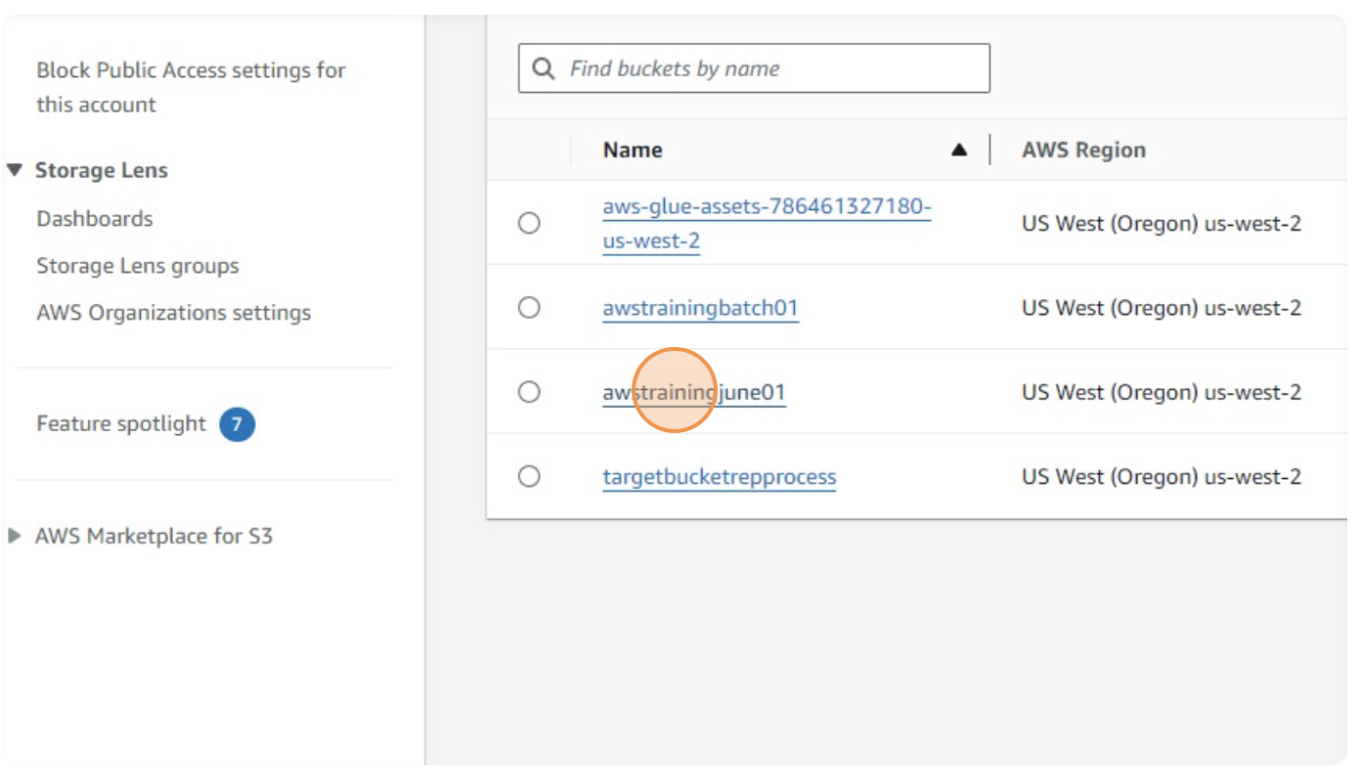

* Navigate within **Output_Data/**

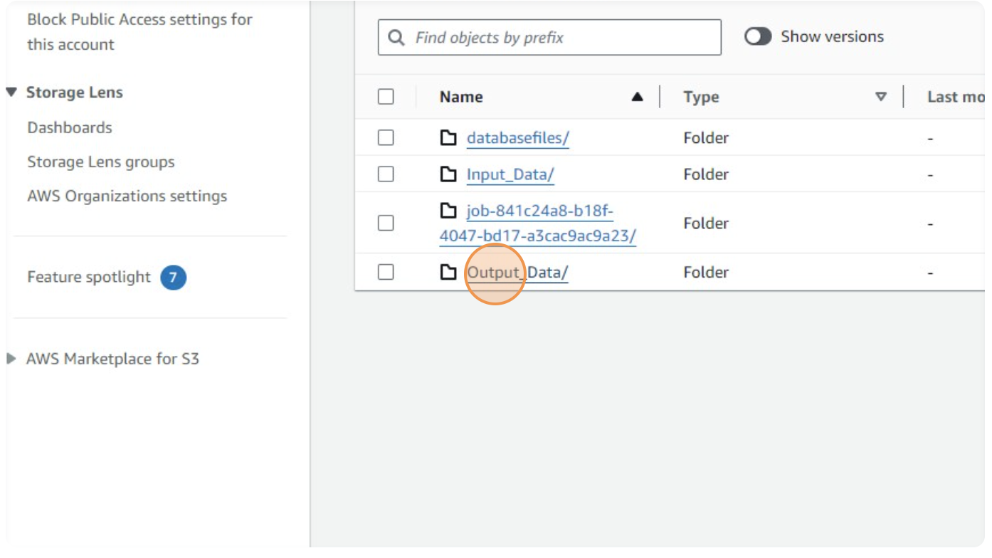

* Click on run-1717068112258-part-block-0-r-00000-snappy.parquet

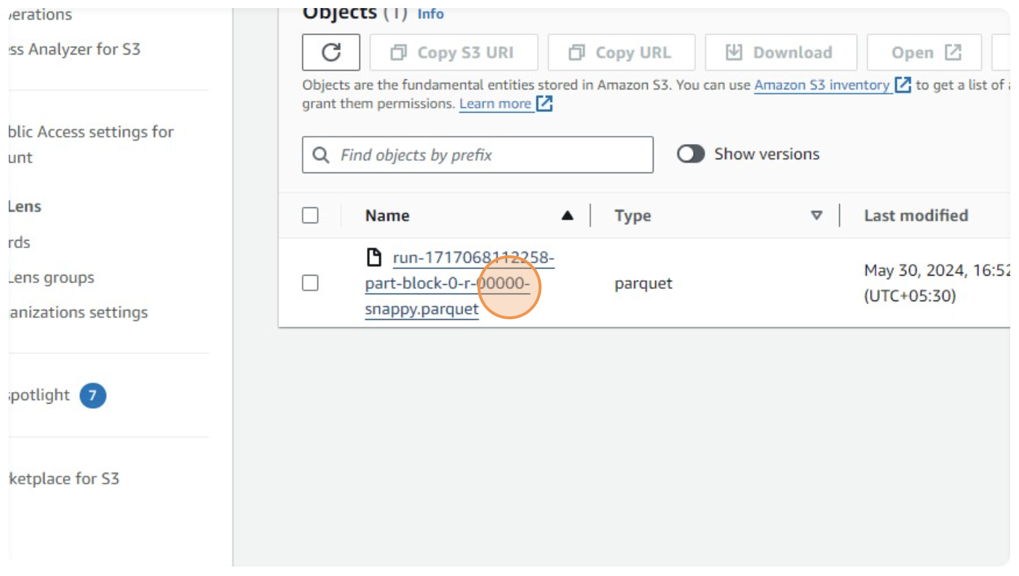

* Download the output Parquet file to verify the successful conversion and ensure the data integrity.

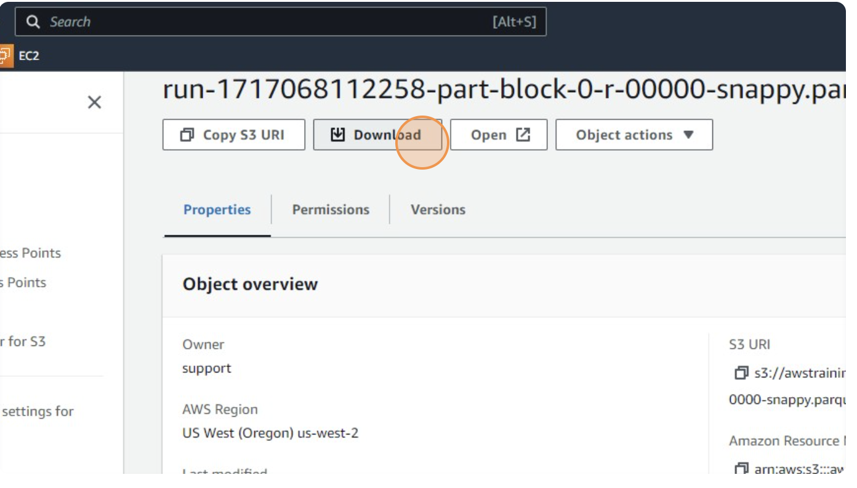

**Voila!!** We have successfully completed this exercise